Batch: B3 Roll No.: 16010121200

Experiment / assignment / tutorial No. 3

Grade: AA / AB / BB / BC / CC / CD /DD

Signature of the Staff In-charge with date

Experiment No: 3

TITLE: Building and configuring simple topology using Network tool - CISCO PACKET TRACER.
______________________________________________________________________________
AIM: To build and configure simple network topology using CISCO Packet Tracer.

Packet Tracer is a network simulation program that allows students to experiment with network behaviour and ask “what if” questions. Packet Tracer provides simulation, visualization, and authoring, assessment, and collaboration capabilities and facilitates the teaching and learning of complex technology concepts.
______________________________________________________________________________
Expected Outcome of Experiment:
CO:
_____________________________________________________________________________
Books/ Journals/ Websites referred:
- A. S. Tanenbaum, “Computer Networks”, Pearson Education, Fourth Edition
- B. A. Forouzan, “Data Communications and Networking”, TMH, Fourth Edition
- CISCO PACKET TRACER 8.0.1 and Higher version (free download)
Pre-Lab/ Prior Concepts: Simple Network flow
______________________________________________________________________________
New Concepts to be learned: Purpose of this lab is to become familiar with building topologies in Packet Tracer. ______________________________________________________________________________
Stepwise-Procedure:

Creating a simple LAN network using packet tracer:
Step 1: Select two PCs (PC0 and PC1) from the end devices and one fast ethernet switch (2950/24 ports)

Step 2: Connect PCs and switch via copper cable from the panel. Connection can be verified by appearance of all green dots on the links.

Step 3: For PCs to communicate click on PC0.
- Dialog box for PC0 appears
- Click on desktop applications by packet tracer.
- Go to IP configuration.
- Enter IP address to identify host i.e. PC0 (for example: 192.168.1.1)
- Subnet mask-by default already set one can change it as per his/her specification.

Step 4: Repeat step 3 for PC1

Step 5: Ping both the PCs and check their working status.

Step 6: Simple PDU (Protocol Data Unit) to simulate network traffic by sending ICMP PDU to assess the network traffic. View simulation in simulation mode

IMPLEMENTATION: (printout of simulation code)

Network Topologies:

- Topology with a HUB
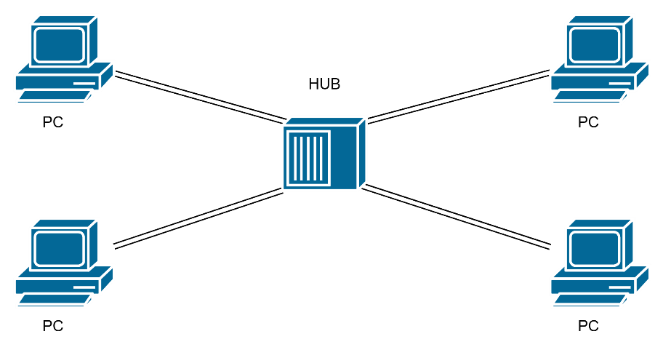
2. Topology with a Switch

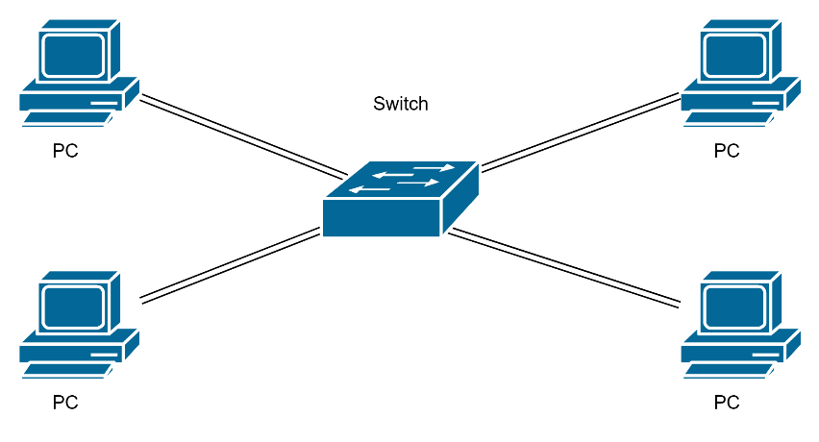

3. Topology with two switches

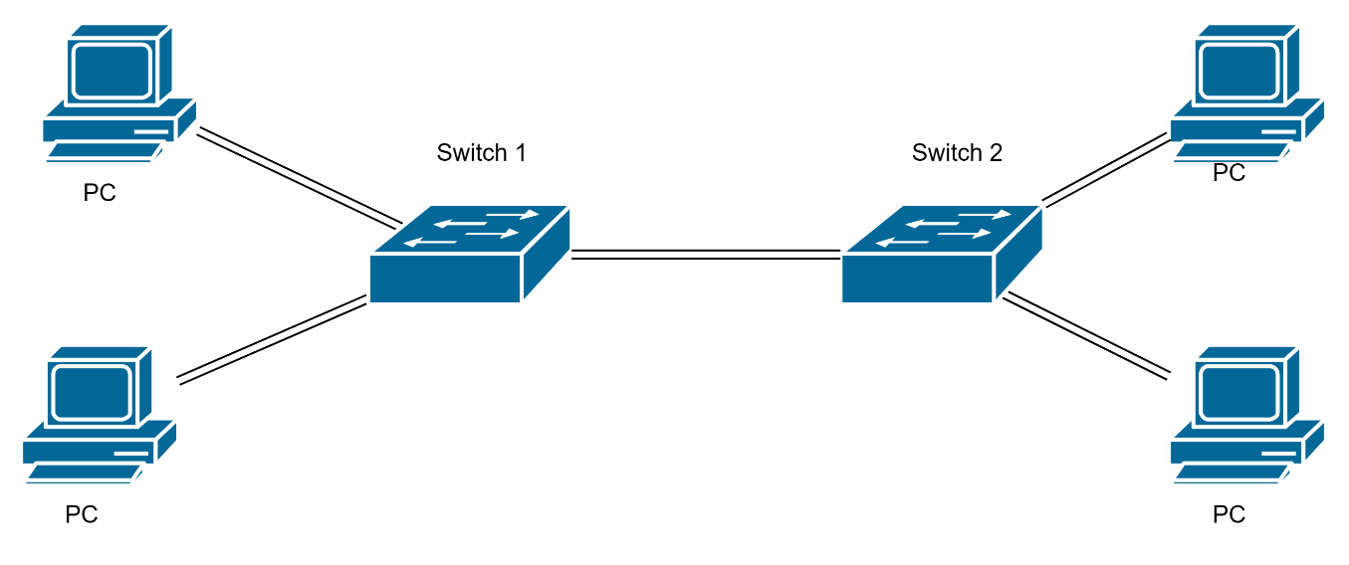

- Topology with 3 switches in a loop (Concept of STP)
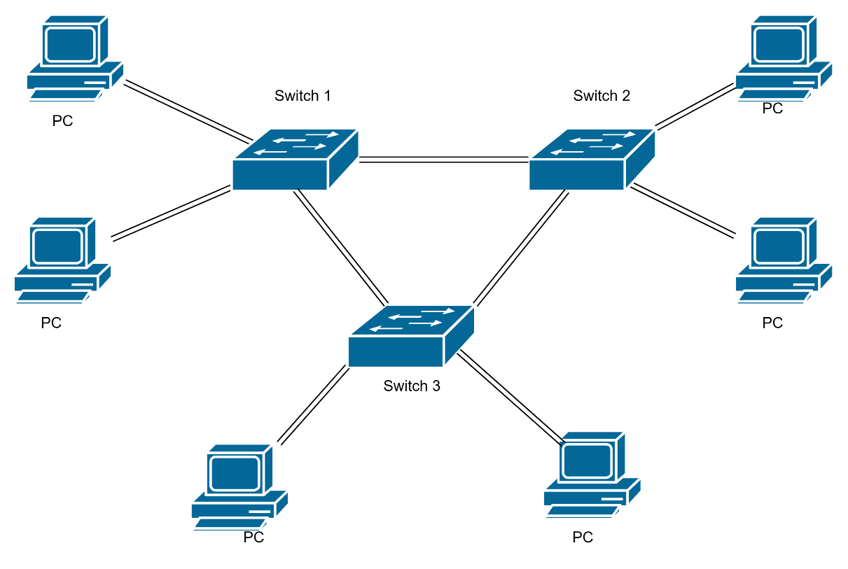

Implementation:

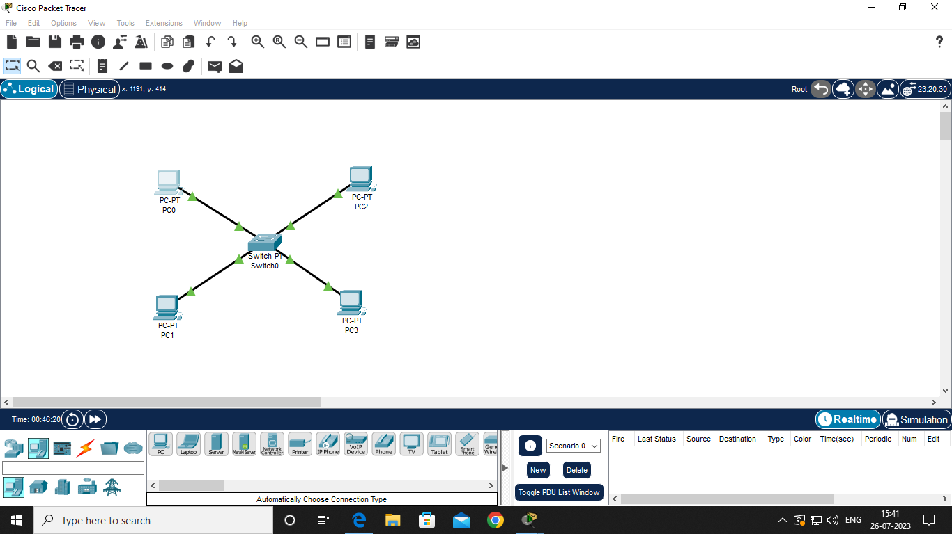

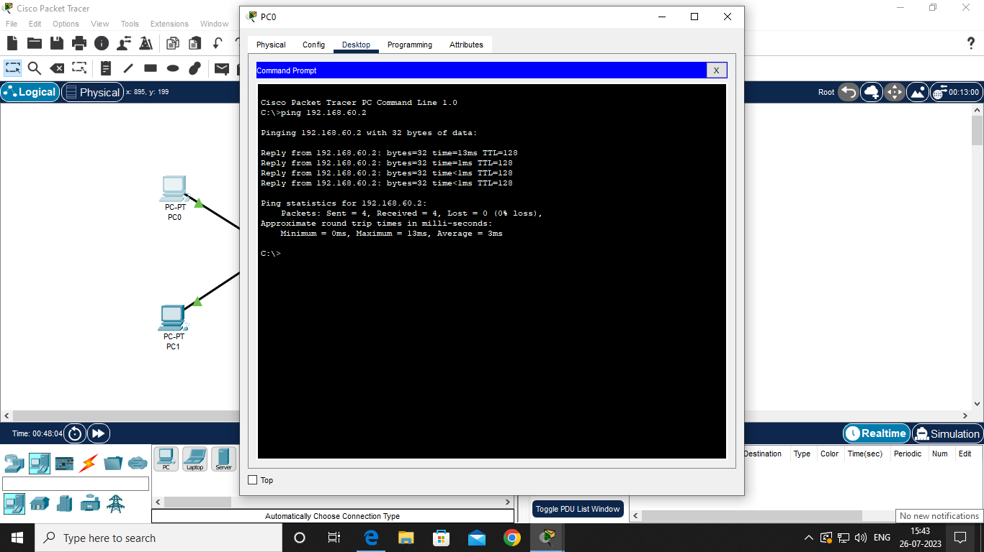

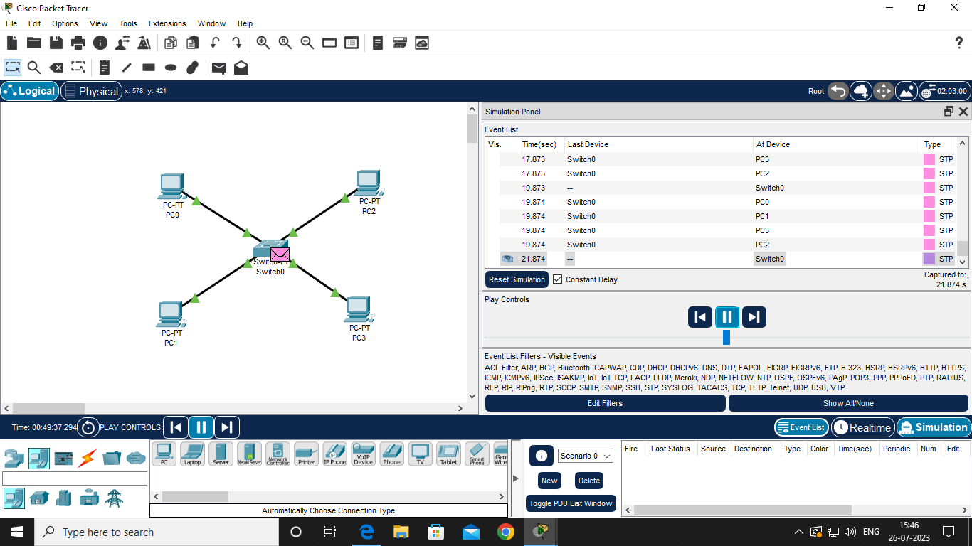

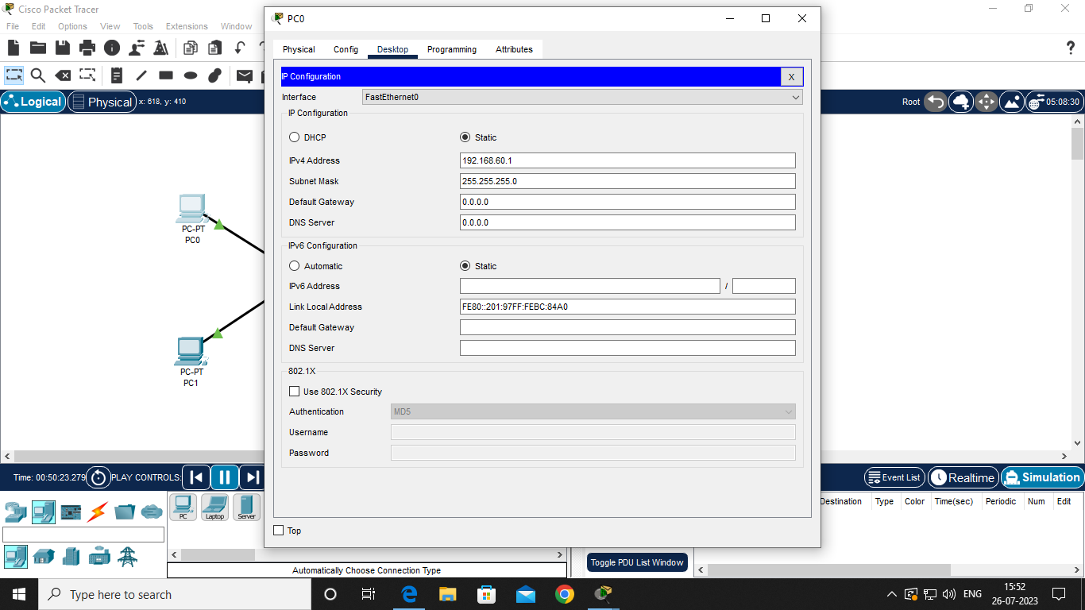

CONCLUSION:
Built and configured simple network topologies using CISCO Packet Tracer.

Post Lab Questions

1. List features of CISCO packet tracer.

- Network Simulation: It allows users to simulate network configurations and interactions, making it a valuable tool for learning networking concepts.
- Device Emulation: Packet Tracer emulates a variety of networking devices, including routers, switches, and end devices, allowing users to create complex network topologies.
- Realistic Network Environment: Users can design and experiment with networks in a virtual environment, replicating real-world scenarios without the need for physical hardware.
- Protocols and Technologies: It supports a wide range of networking protocols and technologies, enabling users to practice concepts like routing, switching, wireless communication, and more.
- Interactive Learning: Packet Tracer offers guided labs and activities that help users learn networking concepts interactively, making it popular in educational settings.
- Multi-User Collaboration: The multi-user feature enables students to collaborate on the same network simulation, facilitating teamwork and communication skills.
- Assessment and Grading: Instructors can use Packet Tracer to create assessments, quizzes, and projects to evaluate students’ understanding of networking concepts.
- IoT Simulations: It includes support for simulating Internet of Things (IoT) devices and connections, allowing users to learn about IoT concepts and applications.
- Visualization: Users can visualize the flow of data through the network using built-in tools like the Packet Tracer Activity Wizard and Packet Tracer Simulation Mode.
- Customization: Users can customize network devices, configure device properties, and modify settings to create specific network scenarios.
- Packet Capture and Analysis: Packet Tracer allows users to capture and analyze network traffic, helping to troubleshoot and diagnose network issues.
- Cross-Platform: It is available for various platforms, including Windows, macOS, and Linux, making it accessible to a wide range of users.

2. Explain difference between working of a Hub and a Switch in a given topology.

Hub:
A hub is a basic networking device that operates at the physical layer of the OSI model. It simply receives data from one device and broadcasts it to all other devices connected to the hub, regardless of whether the data is meant for a specific device or not. This is often referred to as "broadcasting" data. As a result, all devices connected to a hub share the available bandwidth, and network collisions can occur if multiple devices try to transmit data simultaneously. Hubs do not have any intelligence to manage traffic or filter data.

Switch:
A switch operates at the data link layer of the OSI model and is more intelligent than a hub. It maintains a table of MAC addresses (hardware addresses) and uses this table to determine the destination of incoming data frames. When a switch receives data, it checks the destination MAC address and only sends the data to the specific port where the destination device is located. This process is called "switching" and helps prevent unnecessary broadcasting, reducing network congestion and improving overall efficiency. Unlike hubs, switches enable full-duplex communication, allowing devices to transmit and receive data simultaneously without collisions.

In summary, the main difference between a hub and a switch in a network topology lies in how they handle data traffic. Hubs broadcast data to all devices, while switches intelligently direct data only to the intended recipient, leading to better bandwidth utilization and reduced network collisions.

Date: _____________ Signature of faculty in-charge

